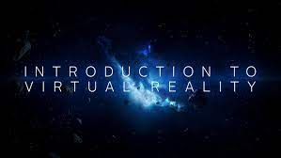

**division of work**

Jiaqi wang:

Explore and introduce the development history of VR.

* Explain the definition of VR, exactly what is VR.
* Introduce important indicators and parameters of VR.
* Display different product forms of VR so far.
* List major events about VR in business history, such as major mergers and acquisitions, investment cases.
* Introduce big companies' plans for VR development.

Songze chen:

Explore and introduce the development barriers and breakthroughs of VR technology.

* Introduce the core technology of VR. Introduce the elements of realizing the VR experience and the corresponding difficulties.
* List the VR technical problems solved(breakthrough) and unsolved so far.
* Explain possible solutions for unresolved issues

Taizhou qing:

Explore and introduce the application and future of VR technology.

* Introduce the possible applications of VR in games, medicine, education, etc.
* Exploring the huge changes that may be brought about in our lives due to the application of VR.
* Introduce the broad market prospect of vr technology. Discuss the possible form and development direction of VR technology in the future.

**Project Scope**:

Discuss the development and application of VR, especially in the field of education. Introduce the problems in the field of education and the corresponding VR solutions. Compare the difference before and after VR application. List the changes in process and efficiency due to the application of VR in the education industry. Explore the greater potential and prospects for industry development due to the application of VR in education.